Coronavirus: keeping healthcare staff and service users safe

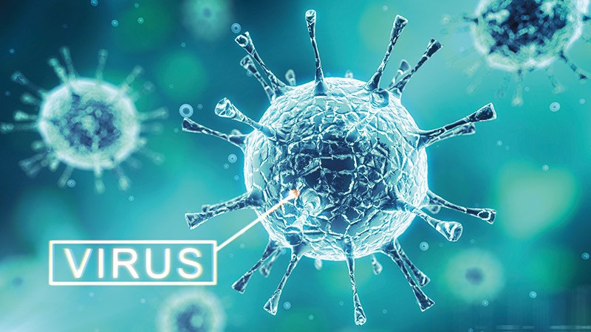

In light of the recent worldwide outbreak of coronavirus (officially named COVID-19), the World Health Organization (WHO) has declared it a pandemic, and the UK Governments has closed schools, pubs, restaurants, cafes, gyms and other businesses to step up their efforts to prepare public health services to treat an increasing number of people with the virus.

The Government has allocated millions of funds to address the implications of the outbreak in the UK and hospitals have been ordered to take new measures.

At SH Care Warrington we pride ourselves on being a responsible employer and patient care is paramount to us. We have prepared the following FAQs to support anyone wishing to learn more about how they can protect themselves, and people in their care, from catching or spreading the virus.

**Frequently asked questions**

What are the signs of the symptoms of coronavirus in humans?

The symptoms of coronavirus are similar those of regular flu. This includes a fever, cough or difficulty breathing.

Coronavirus is likely to cause more severe symptoms in older people or those with underlying medical conditions, such as weakened immune systems, diabetes, cancer and chronic lung disease.

In some severe cases, the coronavirus may progress to pneumonia, causing shortness of breath and other breathing difficulties. The infection can also cause severe acute respiratory syndrome, kidney failure and can ultimately lead to the loss of life.

So far, the evidence indicates that those who have died have had pre-existing health conditions.

What are the health recommendations to prevent the spread of COVID-19?

Current medical advice to prevent the spread of infection from coronaviruses includes:

* Avoiding close contact with people who are exhibiting potential symptoms, such as coughs and sneezes
* Covering the mouth and nose when coughing and sneezing and, if possible, using a tissue to do so, and disposing of it immediately
* Avoiding touching the mouth, nose, or eyes with unwashed hands.
* Clean and disinfect touched objects and surfaces frequently. Use alcohol spray and hand gel
* Self-isolate at home if you experience a persistent cough or high temperature
* No handshakes, hugging or kissing at work
* Only use personal cutlery and crockery
* Regular, thorough hand washing, using soap and water, for at least 20 seconds. This [**NHS video**](https://www.nhs.uk/live-well/healthy-body/best-way-to-wash-your-hands/?utm_campaign=2597012_Coronavirus%20-%20Senior%20Management%20Briefing&utm_medium=email&utm_source=DotDigital&dm_i=2EVT%2C1JNV8%2C8W8S14%2C582H0%2C1)explains the technique in full.

The government's latest advice for workers in the health and social care industries, focusing on community care and residential settings, can be found [**here**](https://www.gov.uk/government/publications/guidance-for-social-or-community-care-and-residential-settings-on-covid-19/guidance-for-social-or-community-care-and-residential-settings-on-covid-19?utm_campaign=11344688_Covid19%20Guidance%2025%202%2020&utm_medium=email&utm_source=UKHCA&dm_i=1DVI,6R5M8,UGSDIM,QZU5A,1).

What should I do if I develop flu-like symptoms?

In line with the government's guidelines, we have advised our staff that they should self-isolate at home for 7 days should they experience the following symptoms:

* a high temperature – you feel hot to touch on your chest or back
* a new, continuous cough – this means you've started coughing repeatedly

They should not:

✖ Go into work

✖ Go to their doctors’ surgery or a hospital

✖ Call NHS 111 to tell them they are staying at home (this guidance has recently changed as we have entered the 'Delay' stage of the government's four-stage plan to combat the virus).

I need to self-isolate. What should I do?

If you experience the above symptoms and need to self-isolate for 7 days, you should do the following:

✔ Try to keep at least 2 metres from other people in your home, particularly older people or those with long-term health conditions

✔ Ask friends or family to assist you with delivery services for food, shopping and medicines, but avoid contact with them. To protect them, you can request that they leave deliveries outside your front door for you to collect

✔ Sleep alone, if possible

✔ Continue to regularly wash your hands with soap and warm water for at least 20 seconds

✔ Ensure that you drink plenty of water and take everyday painkillers, such as paracetamol, to help with your symptoms.

You should not:

✖ Have visitors (ask people to leave deliveries outside)

✖ Leave the house, for example to go for a walk, to school or public places

When should I call NHS 111?

Most people will not need to call NHS 111 and, in self isolation, they will make a full recovery. However, you should call NHS 111 if:

* You feel you cannot cope with your symptoms at home
* Your condition worsens, for example if you struggle to catch your breath
* Your symptoms do not get better after 7 days

Should people wear facemasks?

During normal day-to-day activities, face masks do not provide protection from respiratory viruses, such as COVID-19 and do not need to be worn by staff in any of these settings. Facemasks are only recommended to be worn by infected individuals when advised by a healthcare worker, to reduce the risk of transmitting the infection to other people.

Is there a vaccine for coronavirus?

Not currently. However, researchers are trying to develop a vaccine against the specific strain in question (2019-nCoV) at the time of writing, and the WHO is supporting their efforts.

How can I keep safe when travelling?

Everyone in the UK should avoid "non-essential" travel and contact with others to curb coronavirus.

At SH Care Warrington, we have developed a protocol to avoid all unnecessary travel wherever possible. The global impact of coronavirus and therefore international travel policies are changing every day.

If you are elderly or have pre-existing medical conditions, you are more likely to become ill should you contract the virus. It is recommended that you consider whether travel at this time is the right choice.

For further information on the government's recommendations, please read their dedicated [**travel page**](https://www.gov.uk/guidance/travel-advice-novel-coronavirus).

Further information

Resources on the coronavirus can be found at the following websites.

* The Government’s regularly updated portal - [**click here**](https://www.gov.uk/guidance/wuhan-novel-coronavirus-information-for-the-public)
* The World Health Organization’s dedicated updates page - [**click here**](https://www.who.int/health-topics/coronavirus)
* An interactive map providing real-time updates of coronaviruses across the world, produced by John Hopkins University - [**click here**](https://gisanddata.maps.arcgis.com/apps/opsdashboard/index.html#/bda7594740fd40299423467b48e9ecf6).
* Government advice for workers in the health and social care industries - [**click here**](https://www.gov.uk/government/publications/guidance-for-social-or-community-care-and-residential-settings-on-covid-19/guidance-for-social-or-community-care-and-residential-settings-on-covid-19?utm_campaign=11344688_Covid19%20Guidance%2025%202%2020&utm_medium=email&utm_source=UKHCA&dm_i=1DVI,6R5M8,UGSDIM,QZU5A,1)